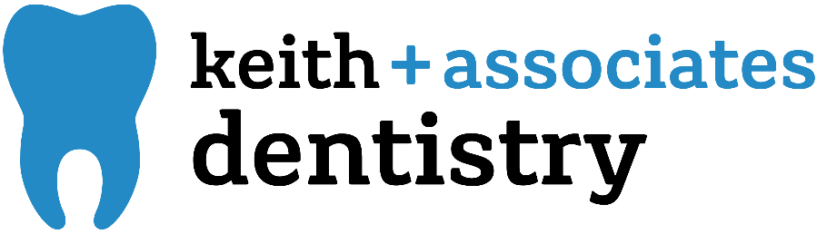

**Maternity Leave Agreement**

At Keith + Associates Dentistry, we are pleased to offer 12 weeks of unpaid maternity time. This means that you can take up to a full 12 weeks off or, come back part time at any point during those 12 weeks (for example: be completely gone for 8 weeks and work 4 weeks part-time). However, to help assist with planning, we must mutually agree upon leave and return dates before your departure.

Due Date: _______________________________

*Anticipated Leave Date: _______________________

Will you want to be scheduled for part-time work? Yes or No

*What day will you come back part-time? __________________________________

What schedule are you anticipating working part-time? ___________________________

*What day will you come back to work full-time? ___________________________________

*If you take your leave early, for any reason, we will adjust your return date to stay in compliance with the plan. Any longer leave time needs to come out of your PTO.

During maternity leave, you will be charged with PTO to maintain your 401 K contributions, health insurance, FSA, or any other applicable benefit. You can choose suspend your 401K contributions while you are out of leave and resume upon your return.

This agreement is to help both K&A and you plan for your exciting new future! We are looking forward to welcoming your little one to the K&A family!!

______________________________________________ _____________

Employee Signature Date

______________________________________________ _____________

Employer Signature Date

________________________________________

Date of Amendment (where applicable)